Name: | ___________________________________________________ |  |  | Date: ___________
 | Year 9 Mathematics  Investigation 3, 2015  Topic – Area and Volume of Similar Figures  In class component |  |  | 55  = %
Total Time: | 60 minutes
Reading Time: | 5 minutes
Working Time: | 55 minutes
Equipment: | Scientific Calculator, Take Home Component
Bonus Marks for Take Home Component: |  | + 1 – ready by due date  + 1 – reasonable attempt made
AIM: In this assessment, you will be investigating the area and volume of similar figures.

1. | [5 marks: 1, 1, 1, 1, 1]
 | Consider the shapes below:
 | 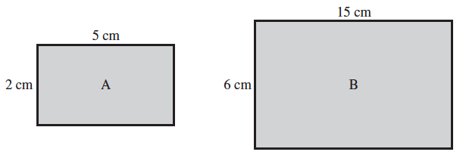
a) | Calculate the perimeter of shape A.
b) | Calculate the perimeter of shape B.
c)
d) | By what scale factor were the side lengths of A increased to get B?
e) | Explain the relationship between the answers to part (c) and (d).

2. | [1 mark]
 | Complete the following sentence:
 | If the side lengths of any figure are increased by a scale factor of n, then the perimeter of similar figures are increased by a scale factor of _________ .

3. | [5 marks: 1, 1, 1, 1, 1]
 | Consider the shapes below:
 | 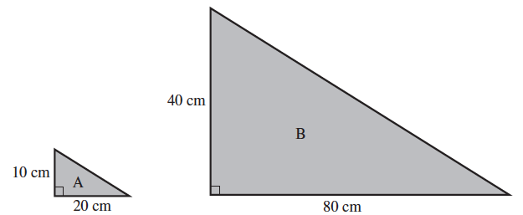
a) | Calculate the area of shape A.
b) | Calculate the area of shape B.
c)
d) | By what scale factor were the side lengths of A increased to get B?
e) | Explain the relationship between the answers to part (c) and (d).

4. | [1 mark]
 | Complete the following sentence:
 | If the side lengths of any figure are increased by a scale factor of n, then the area of similar figures are increased by a scale factor of _________ .

5. | [5 marks: 1, 1, 1, 1, 1]
 | Consider the shapes below:
 | 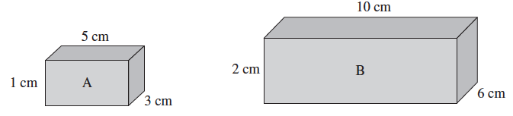
a) | Calculate the volume of shape A.
b) | Calculate the volume of shape B.
c)
d) | By what scale factor were the side lengths of A increased to get B?
e) | Explain the relationship between the answers to part (c) and (d).

6. | [1 mark]
 | Complete the following sentence:
 | If the side lengths of any figure are increased by a scale factor of n, then the volume of similar figures are increased by a scale factor of _________ .

7. | [2 marks]
 | Two kitchen worktops are similar in shape. The perimeter of the smaller worktop is 8 m. | 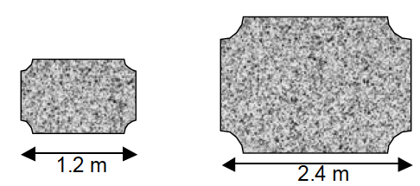
 | Calculate the perimeter of the larger worktop.

8. | [2 marks]
 | Two flags are mathematically similar. The larger flag has an area of 7680 cm². Find the area of the smaller flag. | 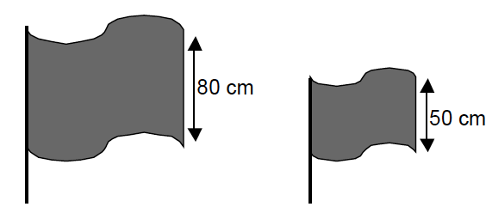

9. | [2 marks]
 | Two metal pipes are similar in shape. The smaller pipe has a volume of 8000 cm³. Find the volume of the larger pipe. | 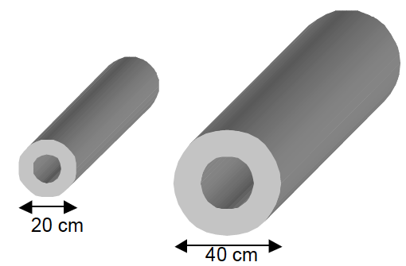

10. | [6 marks: 3, 3]
a) | A triangle has perimeter 10 cm and area 4 cm².  Could you make a similar figure with perimeter 30 cm and area 12 cm²? Why or why not?
b) | A rectangle has perimeter 30 cm and area 25 cm².  Could you make a similar figure with perimeter 6 cm and area 1 cm²? Why or why not?

11. | [7 marks: 1, 2, 2, 1, 1]
 | Consider the similar figures below:
 | 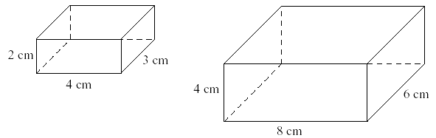
a) | By what scale factor were the side lengths of the smaller prism increased to get the larger prism?
b) | Calculate the surface area of the smaller prism.
c) | Calculate the surface area of the larger prism.
d) | Calculate
e) | Explain the relationship between the answers to parts (a) and (d).

12. | [7 marks: 1, 4, 1, 1]
 | Consider the cubes below:
 | 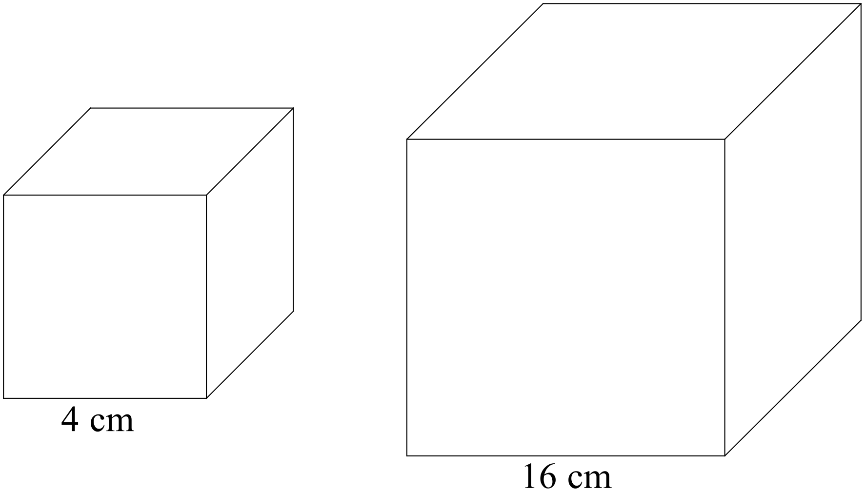
a) | By what scale factor were the side lengths of the smaller cube increased to get the larger cube?
b) | Find the surface area of both of these cubes.
c) | Calculate
d) | Explain the relationship between the answers to parts (a) and (c).

13. | [4 marks: 1, 1, 2]
 | Consider the similar figures drawn below:
 | 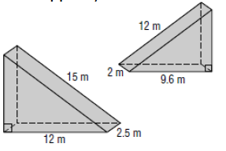
a) | By what scale factor were the side lengths of the larger figure decreased to get the smaller figure?
b) | What will be the scale factor of the surface areas for these figures?
c) | If the surface area of the larger figure is 198 cm², what will be the surface area of the smaller figure?

14. | [1 mark]
 | Complete the following sentence:
 | If the side lengths of any figure are increased by a scale factor of n, then the surface area of similar figures are increased by a scale factor of _________ .

15. | [2 marks]
The dimensions of a regular shape increase by a factor of 4.2.
If the surface area of the original shape is 316 cm², what is the surface area of the larger shape?

16. | [3 marks]
 | A photograph and its enlargement are similar in shape. The smaller photograph has an area of 56 cm², and the larger photograph has an area of 84 cm². If the larger photograph has a length of 18 cm, what is the length of the smaller frame?

